CURRICULAM VITAE
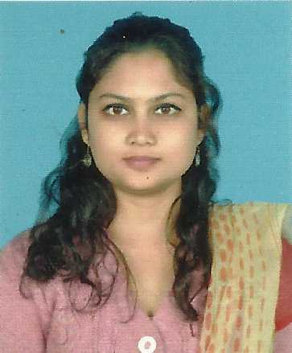

JYOTSNA DEVI
C/O. Kritesh Tripathi
West Milan nagar, Q-lane,Dibrugarh,Assam.
Mobile No: 09678588335, 9854246775
E-mail:devijyotsna88@gmail.com

OBJECTIVE:

Engaging my Knowledge, Skills, Strength and Interest for serving the Society & Pharmaceutical field.

PERSONAL INFORMATION:

Date of Birth : 05-04-1991

Marital Status : Single

Religion : Hinduism

Languages Known : English, Hindi, Assamese, and Bengali

Strengths : Quick learner, Goal Oriented and believes in team
work, Self motivated, Ability to deal with different
people.

EDUCATIONAL SUMMARY:

Professional Qualification:

Sl No. | Examination | University | Year of Passing | Percentage | Division
1. | B.Pharma | Assam Downtown University | 2015 | 64.5% | 1st
General Qualification:

Sl No. | Examination | Board | Year of Passing | Percentage | Division
1. | H.S.S.L.C | CBSE | 2010 | 65.5% | 1st
2. | H.S.L.C | CBSE | 2007 | 71.2% | 1st

Training and Publication details:

Training: I have done my industrial training from Emami Ltd. Abhoypur(Guwahati).

B.Pharmproject title: “preparation and evaluation of bilayer hydrogel tablet”

Instrument Handling:
- 16 station Cadmac
- Karlfischer Apparatus
- Coeffecient viscosity meter
- Single station punching machine
- U.V. double beam photometer
- 6 station dissolution apparatus

AREA OF INTEREST:

- Research and Develpoment
- Quality Control
- Production

ADDRESS:

Present Address | Permanent Address
Town - Dibrugarh  PO - C.R Building  West Milan Nagar,Q-Lane  Dist - Dibrugarh  PIN - 786002 | Vill - Udmari, Borjhargaon  PO - Dekargaon  PS - Tezpur  Dist - Sonitpur  State - Assam  PIN - 784501

HOBBIES:

- Reading Books
- Travelling
- Listening music

COMPUTER SKILLS:

- Basic computer applications

.

WORK EXPERIENCE:

- Worked as a DSO ( Derma Sales Officers) in Hegde & Hegde Pharmaceutica LLP for 6 Months .
- Currently working in Quality Pharma Pvt.Ltd, Lahoal,Dibrugarh in FR&D section since November 2016.

DECLARATION:

I do hereby declare that all the information mentioned above is true to the best of my knowledge and belief.

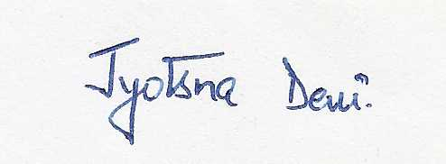
Date : 26-10-2016.

Place : Dibrugarh. Signature

